Precision Engineering and Kernel Optimization for Maximum Token Throughput Across Google Colab Accelerators

Executive Audit of the Provided Precision Specifications
An architectural audit of the six reference documents covering Google Colab’s hardware accelerators—TPU v6e (Trillium), NVIDIA G4 (RTX PRO 6000 Blackwell Server Edition), NVIDIA A100, NVIDIA L4, NVIDIA Tesla T4, and TPU v5e—confirms that their foundational premise is sound¹. Autoregressive large language model (LLM) inference is governed by two distinct hardware regimes: the prefill and high-concurrency batching phase, which is bottlenecked by matrix multiplication compute density (TFLOPS or TOPS), and the low-batch token generation (decode) phase, which is strictly bottlenecked by off-chip memory bandwidth (HBM or GDDR transfer rates)¹. Because generating a single token at batch size requires streaming every active parameter from memory into the execution registers while performing minimal arithmetic per byte fetched, shrinking the byte representation of weights and the Key-Value (KV) cache yields near-linear speedups in single-stream decoding¹.
However, cross-referencing the six documents against low-level compiler documentation, hardware specifications, and kernel execution benchmarks reveals several critical inaccuracies, mathematical inversions, and silicon-level nuances that must be corrected to achieve peak tokens per second in production notebooks.

Technical Corrections and Silicon Nuances by Accelerator
The TPU v6e reference document accurately identifies that a single Trillium chip features 32 GB of High-Bandwidth Memory (HBM) operating at 1,638 to 1,640 GB/s—doubling the 16 GB capacity and 819 GB/s bandwidth of the TPU v5e—and expands the systolic Matrix Multiply Unit (MXU) from to ¹. However, the document claims that TPU v6e executes native FP8 tensor math at 1,836 TFLOPs per chip, doubling the 918 TFLOPs of native bfloat16 (BF16)¹. Official Google Cloud hardware specifications indicate that on TPU v6e, the 1,836 TOPs (2× peak compute) hardware rating applies specifically to INT8 integer arithmetic, whereas peak FP8 compute on v6e is rated at 918 TFLOPs, which is identical to BF16⁸. Native 2× FP8 compute scaling over BF16 (4,614 TFLOPs FP8 vs. 2,307 TFLOPs BF16) arrives with the subsequent TPU v7x (Ironwood) architecture⁹. Consequently, while running FP8 on TPU v6e cuts HBM weight and KV cache traffic by 50% and delivers the stated 1.8× to 2× decode speedup in memory-bound regimes¹, compute-bound prefill and high-batch serving on v6e require W8A8 INT8 (via Accurate Quantized Training/Inference, AQT, or compressed-tensors) to unlock the full 1,836 TOPs systolic array ceiling⁸. Additionally, the document states the decode latency formula as HBM Memory Bandwidth / (Model Weights Size + KV Cache Size)¹; dimensionally, dividing bytes per second by bytes yields inverse latency (tokens per second), whereas true latency per token is bounded by the ratio of total memory footprint to available bandwidth¹⁵:

A second discrepancy arises from a direct contradiction between the TPU v6e and TPU v5e documents regarding 4-bit weight quantization (W4A16). The TPU v6e document advises against W4A16 (INT4 weights, BF16 activations), arguing that dynamic dequantization on the Vector Processing Unit (VPU) degrades memory-bandwidth gains¹. Conversely, the TPU v5e document recommends W4A16 as the winning format at , noting that saving 75% of HBM transfer time dwarfs the VPU unpacking cost⁶. Evaluating the roofline operational intensity resolves this contradiction: TPU v5e has a ridge point of ⁶, whereas TPU v6e has a ridge point of ⁸. Because v6e possesses 4.66× the compute of v5e but only 2× the memory bandwidth, v6e is even more severely memory-bandwidth starved at than v5e¹⁶. Thus, W4A16 (compressed-tensors W4A16 on gmm_v2 or AWQ in vllm-jax) is mathematically superior for single-stream decoding on both TPUs, provided the runtime uses fused grouped matrix multiplication (gmm_v2) or Pallas kernels rather than allowing Hugging Face Transformers to eagerly unpack 4-bit weights into persistent BF16 buffers on the first forward pass¹².
On the NVIDIA side, the G4 document treats NVIDIA Blackwell as a unified execution target, recommending NVFP4 (W4A4) with an FP8 or FP4 KV cache for maximum throughput². While the RTX PRO 6000 Blackwell Server Edition provides 96 GB of GDDR7 ECC memory at 1,597 GB/s and 752 fifth-generation Tensor Cores rated at 4 PFLOPS of peak FP4 compute, 2 PFLOPS of FP8, and 1 PFLOPS of BF16/FP16¹⁹, it is built on the workstation/prosumer Blackwell silicon (Compute Capability SM 12.0 / sm_120) rather than datacenter B200/B300 silicon (Compute Capability SM 10.0 / sm_100)²². Pre-compiled sm_100 binaries crash on sm_120, and unpatched CUTLASS/FlashInfer autotuners on SM120 fall back to non-TMA (Tensor Memory Accelerator) tactics on NVFP4 Mixture-of-Experts (MoE) layers, running at 14.6 tokens/sec—slower than 4-bit Marlin weight-only kernels (46 to 49 tokens/sec)—unless compiled with CUDA 13.0+ targeting the compute_120f architecture suffix²². Furthermore, on SM100+ and SM120 targets, legacy INT8 GEMM dispatch paths are excluded from compilation (gated to 7.5;8.0;8.7;8.9+PTX), meaning INT8 models silently fail to accelerate on Blackwell whereas FP8 executes natively²⁴.
Regarding the NVIDIA A100 (sm_80), the reference document recommends setting kv_cache_dtype="fp8_e5m2" in vLLM to compress the KV cache to 8-bit on Ampere³. While SM80 cannot compile fp8_e4m3 (fp8e4nv) in Triton and relies on fp8_e5m2 for 8-bit storage¹³, empirical testing reveals three critical caveats. First, certain modern model definitions in vLLM (such as Gemma 4) contain hard assertions (assert kv_cache_dtype in {"fp8", "fp8_e4m3"}) that reject fp8_e5m2 outright, forcing Ampere back to BF16/FP16 KV caches¹³. Second, under full CUDA graph capture on SM80, unpatched _insert_kv paths for fp8_e5m2 silently corrupt attention outputs into garbage unless eager breaks or piecewise graphs are used²⁵. Third, because Ampere lacks native FP8 attention hardware and upconverts KV entries to 16-bit in registers, fp8_e5m2 on A100 increases maximum concurrency and context length (~1M tokens) but reduces raw single-stream decode speed to approximately 90% of the BF16 baseline²⁵.
Finally, both the A100 and T4 documents state that FP8 checkpoints must be avoided on these GPUs because native FP8 Tensor Cores require Ada Lovelace (sm_89) or Hopper (sm_90)³. While this holds true for native W8A8 matrix math, vLLM includes a dedicated FP8-Marlin (MarlinFP8ScaledMMLinearKernel) backend that supports Compute Capability , covering both the Turing T4 and Ampere A100²⁷. This kernel executes FP8 checkpoints as weight-only W8A16, streaming 1-byte FP8 weights from memory and dequantizing them inside registers to FP16/BF16 prior to Tensor Core execution²⁸. Similarly, Ampere (sm_80) and Ada (sm_89) can execute NVFP4 checkpoints as weight-only W4A16 via Marlin in-kernel dequantization when enabled via runtime flags³⁰.

Accelerator (Colab Runtime) | Architecture & Compute Cap. | Memory Capacity & Bandwidth | Peak 16-Bit Compute | Peak 8-Bit Compute | Peak 4-Bit Compute | Optimal Low-Batch Decode (B=1–4B=1\text{--}4B=1–4) | Optimal High-Batch Serving (B≥16B \ge 16B≥16)
NVIDIA G4 (RTX PRO 6000) | Blackwell (sm_120 / 120f)² | 96 GB GDDR7 ECC @ 1,597 GB/s¹⁹ | 1,000 TFLOPS (BF16/FP16)²⁰ | 2,000 TFLOPS (FP8 Native)²⁰ | 4,000 TFLOPS (NVFP4/MXFP4)²¹ | NVFP4 / MXFP4 (W4A4) or W4A16 Marlin + FP8/NVFP4 KV² | NVFP4 (W4A4) or FP8 (W8A8) + FP8 KV²
NVIDIA A100 (80GB SXM / 40GB) | Ampere (sm_80)³ | 80 GB @ 2,039 GB/s / 40 GB @ 1,555 GB/s³ | 312 TFLOPS (BF16/FP16)³ | 624 TOPS (INT8 Native; No Native FP8)³ | No Native FP4; INT4 Tensor Core³ | W4A16 (AWQ/GPTQ Marlin) + FP16/BF16 KV³ | W8A8 SmoothQuant INT8 or W4A16 Marlin³
Google TPU v6e (Trillium) | TPU v6e (1 TensorCore, MXU)⁸ | 32 GB HBM @ 1,638–1,640 GB/s⁷ | 918 TFLOPs (BF16 Native; Avoid FP16)¹ | 1,836 TOPs (INT8) / 918 TFLOPs (FP8)⁸ | No Native 4-Bit MXU (VPU Unpack)¹ | W4A16 (gmm_v2 / AWQ) or FP8 (W8A8) + FP8 KV¹ | W8A8 INT8 (AQT) or W8A8 FP8 + FP8 KV¹
NVIDIA L4 | Ada Lovelace (sm_89)⁴ | 24 GB GDDR6 @ 300 GB/s⁴ | 121 TFLOPS Dense (BF16/FP16)⁴ | 242 TFLOPS Dense (FP8 Native)⁴ | No Native FP4; INT4 via Marlin⁴ | W4A16 (AWQ/GPTQ Marlin) + FP8/Auto KV⁴ | FP8 (W8A8) + FP8 KV Cache⁴
Google TPU v5e | TPU v5e (1 TensorCore, MXU)⁶ | 16 GB HBM @ 819 GB/s⁶ | 197 TFLOPs (BF16 Native; Avoid FP16)⁶ | 393 TOPs (INT8 Native; No FP8)⁶ | No Native 4-Bit MXU (VPU Unpack)⁶ | W4A16 (INT4 + BF16) + INT8 Ring KV Cache⁶ | W8A8 INT8 (AQT / MaxText) + INT8 KV Cache⁶
NVIDIA Tesla T4 | Turing (sm_75)⁵ | 16 GB GDDR6 @ 300–320 GB/s⁵ | 65 TFLOPS (FP16 Only; No BF16)⁵ | 130 TOPS (INT8; FP8 via W8A16 Marlin)⁵ | 260 TOPS (INT4 Native; EXL2/Marlin)⁵ | INT4 (EXL2 / AWQ-Marlin / GGUF) + FP16/Q8 KV⁵ | W4A16 AWQ-Marlin or INT8 (W8A8)⁵
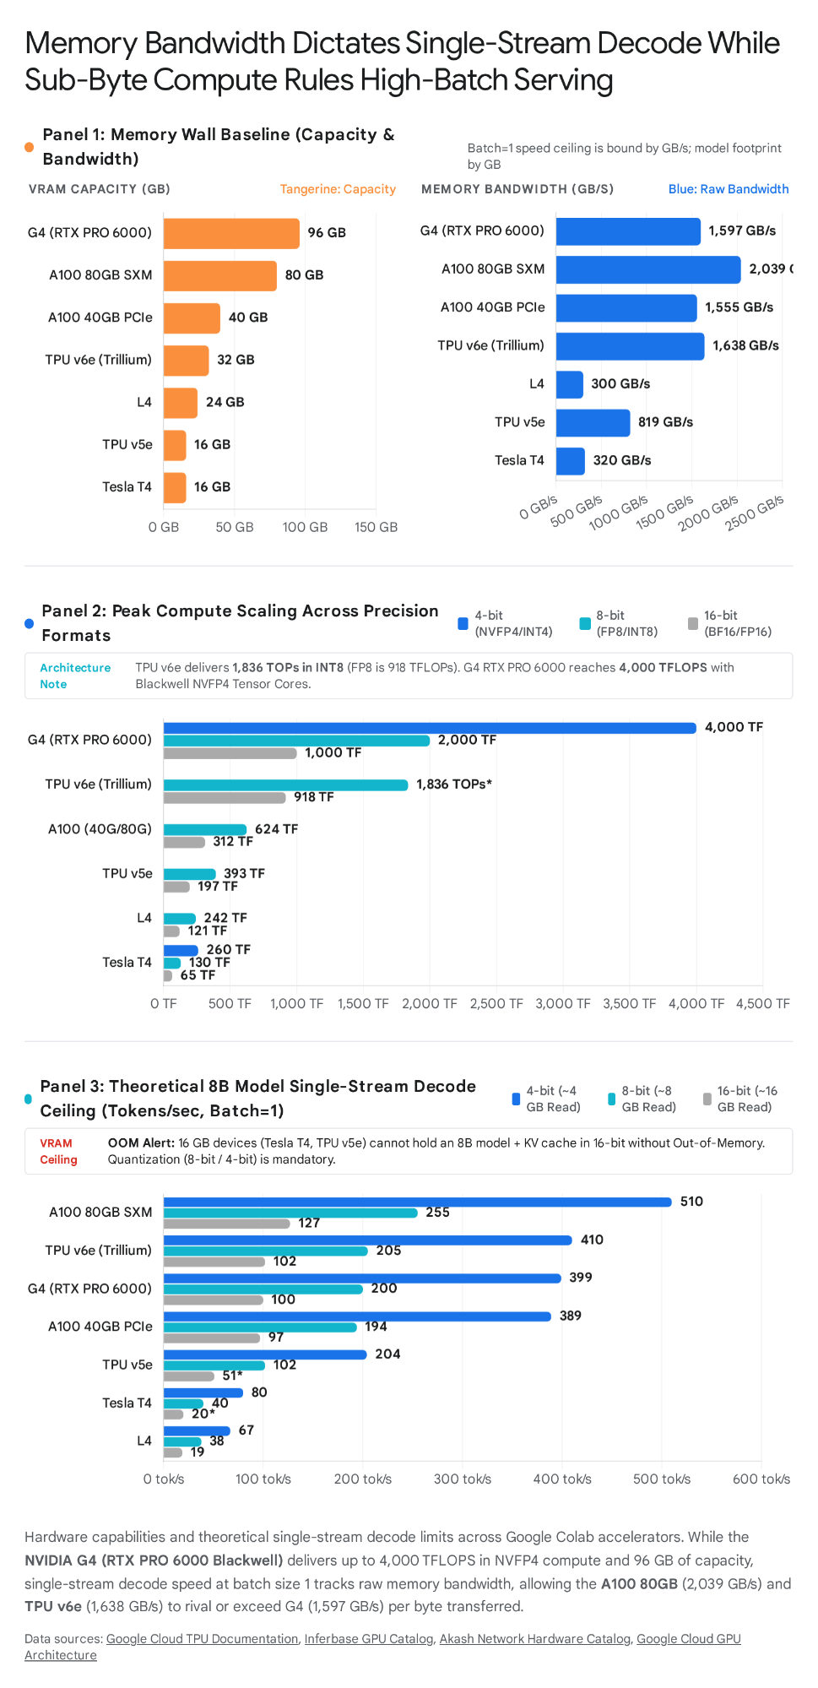

Microarchitectural Deep Dive and Advanced Kernel Tricks by Accelerator
Achieving the theoretical token generation ceilings requires aligning the quantization format with the underlying register file, shared memory hierarchy, and matrix execution units of each accelerator. In standard inference pipelines, loading a quantized checkpoint often fails to deliver the expected speedup because naive dequantization kernels introduce memory round-trips, cache thrashing, or vector unit stalls¹⁵.
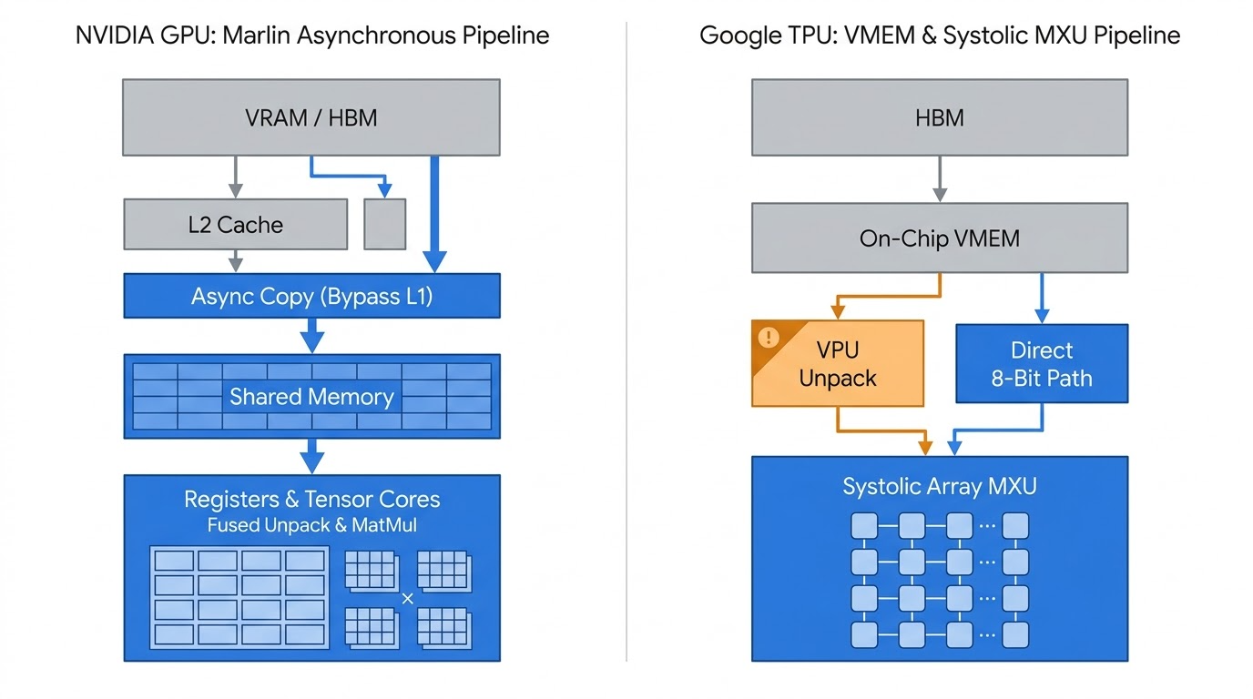

NVIDIA G4 (RTX PRO 6000 Blackwell Server Edition): Navigating the SM120 Frontier
The Google Cloud G4 instance equips the Colab runtime with an NVIDIA RTX PRO 6000 Blackwell Server Edition GPU featuring 96 GB of GDDR7 ECC memory across a 512-bit bus, 1,597 GB/s of memory bandwidth, and a PCIe Gen 5 x16 host interface¹⁹. While the provided documentation rightly identifies NVFP4 (4-bit floating point with microscaling) and FP8 (E4M3) as the premier formats for this card², unlocking its 4 PFLOPS FP4 and 2 PFLOPS FP8 Tensor Core ceiling requires overcoming several software-stack traps specific to its SM 12.0 (sm_120) compute capability²¹. Despite sharing the Blackwell brand with the datacenter B200 (sm_100), the RTX PRO 6000 reports device capability 12.0 (sm_120)²². Standard CUTLASS templates compiled with compute_120a fail to initialize Tensor Memory Accelerator (TMA) Warp-Specialized (WS) grouped GEMM tactics on SM120, causing the FlashInfer autotuner to fall back to slow non-TMA kernels—yielding only 14.6 tokens/sec on NVFP4 MoE models—or to produce corrupted output due to missing Grid Dependency Control (griddepcontrol.wait/launch) barriers²². Compiling with CUDA 13.0+ and the compute_120f ("full" feature set) target flag unlocks fast TMA WS grouped GEMM tactics on SM120, nearly tripling native FP4 MoE generation speed to 39.0+ tokens/sec²². In Colab, practitioners must install the CUDA 13 FlashInfer wheel (pip install flashinfer-python[cu13]) alongside pre-compiled cubins (flashinfer install-cubin-wheel) to ensure these SM120 paths are active³⁹.
To maximize execution efficiency across different layer types on SM120, a hybrid backend routing strategy is required. Setting the environment variable VLLM_NVFP4_GEMM_BACKEND=cutlass directs dense linear projections to utilize vLLM’s native CUTLASS kernels²², while setting VLLM_USE_FLASHINFER_MOE_FP4=1 exclusively when serving Mixture-of-Experts architectures activates FlashInfer’s fused FP4 MoE routing⁴⁰. Furthermore, when running an fp8 or nvfp4 quantized KV cache on SM120 using FlashInfer’s XQA decode path, full CUDA graph capture (FULL) silently corrupts attention outputs³². Passing --compilation-config '{"cudagraph_mode":"PIECEWISE"}' in vLLM isolates the attention decode step from full-graph capture corruption while preserving graph acceleration across all linear layers, enabling a 244,928-token KV cache ceiling (compared to approximately 163,000 tokens in FP8) at 95.6 tokens/sec single-stream on 27B hybrid architectures³².
Beyond NVIDIA’s proprietary nvfp4 format (generated via modelopt), recent FlashInfer releases for SM120 (b12x) introduce native MXFP4 (Open Compute Microscaling 4-bit float) support across W4A4 fused MoE, W4A8/W4A16, and dense GEMMs³¹. These releases also incorporate Tensor Memory (TMEM) overlap for NVFP4 SwiGLU epilogues and QKV projections, as well as asymmetric VO-split NVFP4 paged prefill (qk=512/vo=256) for architectures such as Gemma 4³¹. Finally, because the RTX PRO 6000 Server Edition supports Universal Multi-Instance GPU (MIG), a single 96 GB Colab G4 card can be partitioned into up to four isolated 24 GB hardware instances (4x 24GB MIG), each with dedicated GDDR7 memory controllers, L2 cache, and Tensor Cores¹⁹. When running batch evaluations of 7B to 14B models in FP8 or NVFP4, deploying four parallel data-parallel workers across four MIG slices eliminates multi-stream scheduling contention.

NVIDIA A100 (40GB / 80GB) and L4: Exploiting the Marlin Pipeline and FlashInfer
On the NVIDIA A100 (sm_80, 1,555 to 2,039 GB/s HBM2e) and NVIDIA L4 (sm_89, 300 GB/s GDDR6), the primary determinant of low-batch decode speed is not merely choosing 4-bit weights (W4A16), but specifically routing execution through the Marlin kernel (awq_marlin or gptq_marlin)³. Standard GPTQ and AWQ inference kernels suffer from synchronous memory loads, random access patterns that yield poor L2 cache hit rates (30–50%), L1 cache pollution from streaming weights, and un-fused dequantization in the critical path³³. In empirical benchmarks on Qwen2.5-32B-Instruct, switching from standard AWQ to Marlin-AWQ increases throughput from 68 tokens/sec to 741 tokens/sec (a 10.9× speedup), while Marlin-GPTQ jumps from 276 tokens/sec to 712 tokens/sec (a 2.6× speedup)³³. Marlin achieves near-100% memory bandwidth utilization through four coordinated hardware mechanisms: it uses asynchronous copy instructions (cp.async) to stream packed 4-bit weights from DRAM through the L2 cache directly into Shared Memory (SMEM), bypassing the L1 cache entirely so L1 remains dedicated to activations; it orders weight tiles for spatial and temporal locality, raising L2 cache hit rates to 80–95%; it implements SMEM double buffering so tile loads asynchronously in the background while Tensor Cores compute on tile ; and it fuses dequantization with computation by unpacking 4-bit weights to 16-bit inside the register file immediately prior to warp-level Tensor Core matrix-multiply-accumulate (MMA) instructions, eliminating intermediate global memory writes³³.
This asynchronous register-dequantization architecture also enables cross-format emulation on older Tensor Cores. Although the A100 lacks native FP8 and FP4 hardware³, it can execute modern FP8 checkpoints at high speed using FP8-Marlin (W8A16), which packs weights in 1-byte FP8 in HBM and dequantizes them in-register to FP16/BF16²⁷. Similarly, setting NIM_ALLOW_NVFP4_EMULATION=1 on vLLM or SGLang allows Ampere (sm_80) and Ada (sm_89) GPUs to run Blackwell NVFP4 checkpoints by dequantizing FP4 weights to BF16 in-kernel via Marlin³⁰. Conversely, when running native W8A8 FP8 on the L4 at batch sizes , practitioners should select FP8 checkpoints calibrated with static per-tensor activation scales over dynamic per-tensor activation scales⁴. Dynamic scaling computes the absolute maximum (amax) of activation tensors on every forward pass, introducing reduction kernel overhead that degrades latency on the L4's modest SM count, whereas static scales fuse the scaling factor directly into the CUTLASS FP8 GEMM epilogue⁴³.
Both the A100 and L4 further benefit from attention-layer and sparsity optimizations. Standard PagedAttention implementations copy non-contiguous KV cache pages into a contiguous temporary buffer before launching the attention kernel⁴⁰. Setting VLLM_ATTENTION_BACKEND=FLASHINFER (or --attention-backend FLASHINFER) activates BatchPrefillWithPagedKVCacheWrapper and BatchDecodeWithPagedKVCacheWrapper, which operate directly on non-contiguous paged KV blocks and deliver a 28–30% speedup on long-context (32K+) workloads⁴⁰. Pre-installing the flashinfer-cubin and flashinfer-jit-cache wheels in Colab eliminates the 1-to-5 request JIT compilation warm-up penalty³⁹. Additionally, Ampere (sm_80) and Ada Lovelace (sm_89) Tensor Cores include hardware Sparse Tensor Core units that double raw compute throughput (from 312 to 624 TFLOPS on A100, and 242 to 484 TFLOPS FP8 on L4) when weights follow a 2:4 semi-structured sparsity pattern (two non-zero values per four-element block)³. In vLLM, compressed_tensors_24 schemes and sparse TensorRT-LLM engines exploit this hardware path to accelerate compute-bound prefill and high-batch generation⁴¹.

NVIDIA Tesla T4 (Turing SM75): Squeezing Maximum Bandwidth from Legacy Silicon
The Tesla T4 (sm_75, 16 GB GDDR6, ~300–320 GB/s bandwidth) lacks bfloat16 and native fp8 hardware, making float16 and integer quantization (INT8/INT4) mandatory⁵. Beyond the standard recommendation of AWQ, GPTQ, or EXL2⁵, three specific kernel and quantization optimizations unlock substantially higher throughput on T4 Colab instances. First, vLLM’s minimum compute capability gate for awq_marlin, gptq_marlin, and fp8 (weight-only W8A16 via FP8-Marlin) is 75 (sm_75)²⁷. While native FP8 W8A8 fails on the T4, loading an FP8 or AWQ model in vLLM on a T4 utilizes the Marlin weight-only dequantization path to stream 8-bit or 4-bit weights over the 320 GB/s bus and execute math on Turing's FP16 Tensor Cores²⁸.
Second, because the T4 has a strict 16 GB VRAM ceiling, standard 4.0-bit quantization struggles to fit 14B to 32B models alongside a usable KV cache⁵. ExLlamaV2’s EXL2 format supports mixed fractional bitrates across layers and heads (such as 3.0 to 3.75 bits per weight average, assigning 4 to 6 bits to sensitive attention projections and 2 to 3 bits to MLP down-projections), enabling a 27B or 32B model to fit entirely within 16 GB VRAM while decoding at 25 to 40 tokens/sec via custom register-fused CUDA kernels⁵. Third, when deploying GGUF models on a T4, compiling llama.cpp with -DGGML_CUDA_FORCE_MMQ=ON forces Matrix Multiply Quantized (MMQ) kernels that utilize Turing's native 260 TOPS INT4/INT8 dot-product instructions rather than dequantizing to FP16 for cuBLAS⁵. Pairing this build flag with -ctk q8_0 -ctv q8_0 (or q4_0) and -fa (FlashAttention) quantizes the KV cache to 8-bit or 4-bit integers, halving memory bandwidth overhead at context lengths above 2,048 tokens⁵.

Google Cloud TPU v6e (Trillium) and TPU v5e: XLA Lowering, TorchTPU, and Pallas Kernels
Running LLMs on Google Colab’s TPU v5e (16 GB HBM, 819 GB/s) and TPU v6e (32 GB HBM, 1,638 GB/s) requires a fundamentally different optimization paradigm than CUDA GPUs because TPUs rely on ahead-of-time and just-in-time whole-graph compilation via OpenXLA rather than dynamic per-operator kernel launches⁸. The TPU software stack has transitioned away from legacy Lazy Tensor torch_xla toward two high-performance pathways: TorchTPU (torch_tpu) for native PyTorch (model.to("tpu") and torch.compile(model, backend="tpu"))⁴⁷, and vllm-jax (formerly tpu-inference) for unified JAX/PyTorch serving via vLLM⁵⁰. On a single Colab TPU v5e-1 chip, running PyTorch in strict eager mode yields only 5.0 tokens/sec, and TORCH_TPU_DEFER_AND_FUSE=1 reaches only 9.1 tokens/sec while suffering a 359-second initial compilation stall because autoregressive generation grows sequence length by 1 token per step, triggering a fresh XLA compilation for every shape¹⁸. Wrapping the decode step in torch.compile(backend="tpu") with Bounded Dynamism and a fixed-size Ring KV Cache eliminates shape recompilations and boosts single-chip v5e-1 decode speed to 45.3 to 50.0 tokens/sec—a 10× speedup over eager mode—while holding a 131,328-token context window in just 0.82 GB of HBM¹⁸.
Even after graph compilation, a hidden bottleneck on Colab TPU runtimes is token-by-token host synchronization. If a Python generation loop reads each newly sampled token ID back from the TPU to the CPU host on every step for live text streaming, PCIe round-trip latency artificially caps TPU v5e-1 throughput at 31.8 to 37.2 tokens/sec, completely erasing the speed advantage of 4-bit quantization¹⁸. Accumulating generated token IDs inside an on-chip HBM buffer across the generation window and reading them back to the host in multi-token chunks or at End-of-Sequence (EOS) immediately restores throughput to 45–50+ tokens/sec¹⁸.
Maintaining true sub-byte weight compression in HBM is equally critical on TPUs. Standard Hugging Face compressed-tensors integrations unpack every 4-bit layer to bfloat16 during the first forward pass and retain the unpacked BF16 weights in HBM, negating both memory savings and bandwidth speedups¹⁸. To execute true W4A16 on TPUs, vllm-jax provides the compressed-tensors W4A16 on gmm_v2 linear method, which retains 4-bit packed weights in HBM and unpacks tiles inside Vector Memory (VMEM) during the grouped matrix multiply¹⁷. Furthermore, for models with large vocabularies (such as Gemma), keeping the embedding table quantized on a 4-bit integer grid with a per-row bfloat16 scale factor (self.embed_scale) frees 3.4 GB of HBM on a v5e-1 chip (dropping the loaded footprint from 9.82 GB to 6.44 GB, which is vital when XLA compilation peak memory reaches 16.67 GB against the chip's 16 GiB / 17.2 GB physical limit) and accelerates the compiled decode step by 1.51× to 1.60×¹⁸.
When implementing blockwise (subchannel) FP8 or INT4 quantization via QWIX, Tokamax (use_tokamax_gmm=True), or custom Pallas kernels on TPU v6e (or v7), tensor block dimensions must be multiples of 256 to match the expanded systolic array⁹. Empirical profiling demonstrates that subchannel block sizes smaller than 384 (such as ) starve the MXU and make the kernel VPU-bound due to per-block scale multiplication overhead, causing quantized dot_general operations to run slower than unquantized BF16³⁶. Using per-channel scaling or block sizes of or written directly inside Pallas kernels restores the full ~2× hardware speedup³⁶. Finally, in vllm-jax on TPU v6e and v5e, passing --attention-backend to select Ragged Paged Attention V3 (Batched or Stacked RPA v3) stops over-fetching KV pages during decode and removes mixed-batch padding penalties during speculative verification¹². Because TPU v6e also integrates two SparseCores per chip⁸, pinning embedding gather operations and collective communications to a dedicated SparseCore stream (torch.tpu.Stream(pinned="sparse")) in TorchTPU and XLA overlaps communication and sparse lookups asynchronously with MXU matrix multiplications⁴⁷.

Cross-Platform Algorithmic and Runtime Accelerators for Google Colab
Beyond hardware-specific precision formats and low-level kernels, engine-level algorithmic transformations can multiply effective token generation speed across all six accelerators without sacrificing output accuracy.
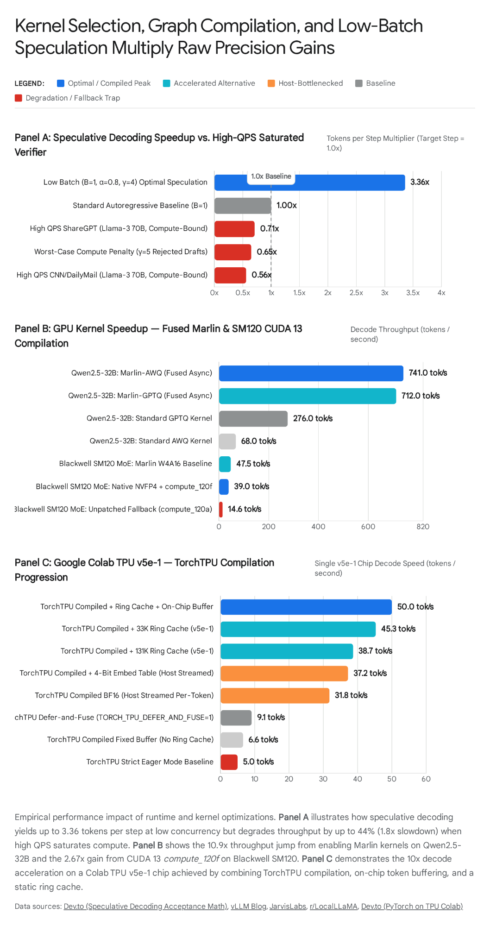

Speculative Decoding: Turning Idle Compute into Memory Bandwidth Multiplication
During single-stream or small-batch autoregressive decoding (), generating a token performs roughly 1 to 2 FLOPs per byte of weight data read from memory⁵¹. Because modern accelerators have arithmetic intensity ridge points between 200 and 2,500 FLOPs/byte, the Tensor Cores or MXUs sit idle for the vast majority of each decode step while waiting on memory transfers⁵¹. Speculative decoding exploits this idle compute by proposing candidate tokens cheaply and verifying all positions in a single parallel forward pass of the target model, thereby reading the target model’s weights from memory only once⁵¹. Assuming each proposed token is accepted with probability and a single draft step costs a fraction of a target forward pass, the expected number of generated tokens per target step and the resulting net speedup in the memory-bound regime are governed by⁵¹:

At and , the target model emits an average of 3.36 tokens per weight read while guaranteeing a mathematically identical output distribution via modified rejection sampling⁵¹. On 16 GB to 24 GB accelerators (T4, L4, TPU v5e) where loading a separate draft model competes with the KV cache for scarce memory⁵², practitioners should enable Prompt Lookup (N-Gram) Speculative Decoding (--speculative-config '{"method": "ngram", "num_speculative_tokens": 5, "prompt_lookup_max": 5, "prompt_lookup_min": 2}')⁵². This technique requires zero additional VRAM () by matching 2-to-5 token n-grams from the current generation suffix against earlier tokens in the prompt and copying the subsequent span⁵². For input-echoing workloads—such as Retrieval-Augmented Generation (RAG), document summarization, JSON extraction, and code refactoring—n-gram lookup provides a 1.8× to 2.5× speedup at zero memory cost⁵¹.
For open-ended generation, mathematical reasoning, or chat on high-capacity accelerators (G4, A100, TPU v6e) where outputs do not repeat the prompt, n-gram lookup yields low acceptance rates⁵². In these scenarios, Multi-Token Prediction (--method mtp) on architectures with built-in MTP heads (such as Qwen3.5/3.6 or DeepSeek) achieves 91% to 100% token acceptance rates on Blackwell SM120³², while lightweight EAGLE-3 (--method eagle3) or Arctic MLP speculators can be quantized to FP8 to minimize draft latency ⁵². On TPUs, vllm-jax and vLLM-TorchTPU natively support speculative decoding, and recent vllm-jax releases optimize the Batched RPA kernel to categorize speculative verification as a decode operation rather than a mixed prefill, eliminating padding overhead¹⁷.
Crucially, speculative decoding is strictly a low-concurrency optimization⁵¹. Once concurrent batch size increases and the accelerator becomes compute-bound, verifying tokens costs roughly times the compute of a single token⁵¹:

Under high QPS on 70B models, unthrottled speculative decoding causes a 1.4× slowdown on ShareGPT and a 1.8× slowdown on CNN/DailyMail, dropping effective throughput to 0.56×–0.71× of the non-speculative baseline⁵¹. To prevent high-batch degradation in vLLM, configurations must keep num_speculative_tokens between 2 and 4 (or up to 5 for structured code/JSON)⁵¹, set --speculative-disable-by-batch-size 4 (or 8) so the scheduler automatically disables speculation when active concurrency crosses into the compute-bound regime⁵¹, and leave --disable-logprobs-during-spec-decoding enabled (True by default) to skip redundant log-probability calculations across proposal, target, and rejection steps⁵⁴.

Memory Subsystem, Compiler Flags, and Colab I/O Tuning
Because Google Colab instances operate inside virtualized container environments with network-attached storage and session timeouts, runtime initialization and memory scheduling settings significantly impact sustained token generation rates. Enabling --enable-chunked-prefill splits long incoming prompts into bounded token chunks (--max-num-batched-tokens), piggybacking prefill compute onto active decode batches so a single long prompt does not stall inter-token latency (TPOT) for concurrent streams or trigger activation OOM spikes²⁵. Pairing this with --enable-prefix-caching retains KV cache blocks for shared system prompts or multi-turn histories in memory, which is supported across both CUDA GPUs and hybrid linear-attention models on TPUs (mamba_cache_mode="align")¹⁷.
At the scheduler and loss-computation level, increasing --num-scheduler-steps (e.g., to 4 or 8) in vLLM allows the engine to execute multiple consecutive forward passes on the accelerator before returning control to the Python scheduler, hiding CPU overhead on fast GPUs like the G4 and A100⁵⁴. For training or fine-tuning runs on TPUs via MaxText, setting num_vocab_tiling=8 tiles the cross-entropy loss logit projection across the vocabulary dimension, substantially reducing peak HBM usage so larger batch sizes fit in memory³⁶. Finally, because loading multi-gigabyte checkpoints in Colab frequently bottlenecks on virtual disk I/O, passing --load-format fastsafetensors in vLLM uses direct zero-copy memory transfers to load 27B quantized checkpoints in 1.69 to 3.04 seconds²⁷. To avoid paying a 5-to-10 minute XLA compilation or FlashInfer JIT compilation penalty every time a Colab runtime disconnects, mounting Google Drive or a Google Cloud Storage (GCS) bucket and pointing FlashInfer’s JIT cache (export FLASHINFER_CACHE_DIR=/content/drive/MyDrive/flashinfer_cache) on GPUs⁴⁰ and TorchTPU / OpenXLA’s Tier-3 Persistent Compilation Cache on TPUs⁴⁷ to persistent storage ensures immediate warm-start execution across notebook sessions.

Synthesis of Optimal Configurations for Google Colab Workloads
The following deployment matrix consolidates the corrected precision formats, specialized kernel backends, and runtime execution flags required to achieve peak token generation throughput across every accelerator available on the Google AI Colab plan.

Colab Hardware Target | Workload Regime | Optimal Precision & Checkpoint Format | Primary Engine & Kernel Backend | Mandatory Runtime Flags & Environment Settings
G4 GPU (RTX PRO 6000 Blackwell, 96 GB) | Low-Batch Decode () | NVFP4 / MXFP4 (W4A4) or AWQ/GPTQ (W4A16) + FP8 / NVFP4 KV Cache² | vLLM / SGLang with FlashInfer (cu13 + compute_120f) & CUTLASS²² | pip install flashinfer-python[cu13]; VLLM_NVFP4_GEMM_BACKEND=cutlass; VLLM_USE_FLASHINFER_MOE_FP4=1 (if MoE); --compilation-config '{"cudagraph_mode":"PIECEWISE"}'; --speculative-config '{"method":"mtp","num_speculative_tokens":3}'²²
G4 GPU (RTX PRO 6000 Blackwell, 96 GB) | High-Batch Serving () | NVFP4 (W4A4) or Static FP8 (W8A8 E4M3) + FP8 KV Cache² | vLLM / TensorRT-LLM with 5th-Gen Tensor Core FP4/FP8 GEMM² | --kv-cache-dtype fp8; --enable-chunked-prefill; --enable-prefix-caching; --gpu-memory-utilization 0.95; optional 4× 24 GB MIG partitioning for multi-worker data parallelism²
A100 (40 GB PCIe / 80 GB SXM) | Low-Batch Decode () | W4A16 (AWQ / GPTQ) or W8A16 (FP8 Checkpoint) + FP16/BF16 KV Cache³ | vLLM with awq_marlin / gptq_marlin / fp8 (Marlin) + FlashInfer³ | --quantization awq_marlin; VLLM_ATTENTION_BACKEND=FLASHINFER; --speculative-config (EAGLE-3 or N-Gram with --speculative-disable-by-batch-size 4); avoid fp8_e5m2 KV cache unless memory-capacity bound³
A100 (40 GB PCIe / 80 GB SXM) | High-Batch Serving () | W8A8 SmoothQuant INT8 or W4A16 Marlin (with 2:4 Sparsity if available)³ | TensorRT-LLM or vLLM (INT8 Tensor Cores @ 624 TOPS)³ | --enable-chunked-prefill; --enable-prefix-caching; torch.backends.cuda.matmul.allow_tf32 = True; use kv_cache_dtype="fp8_e5m2" only with piecewise/eager-break patch if 100K+ context requires 8-bit KV³
L4 GPU (Ada Lovelace, 24 GB) | Low-Batch Decode () | W4A16 (AWQ / GPTQ) + FP8 KV Cache⁴ | vLLM with awq_marlin / gptq_marlin + FlashInfer⁴ | --quantization awq_marlin; --kv-cache-dtype fp8; VLLM_ATTENTION_BACKEND=FLASHINFER; --speculative-config '{"method":"ngram","num_speculative_tokens":5}' for RAG/code⁴
L4 GPU (Ada Lovelace, 24 GB) | High-Batch Serving () | Static FP8 (W8A8 E4M3) + FP8 KV Cache⁴ | vLLM / TensorRT-LLM (Ada FP8 Tensor Cores @ 242 TFLOPS)⁴ | --quantization fp8 (prefer static activation scales); --kv-cache-dtype fp8; --enable-chunked-prefill; --gpu-memory-utilization 0.92⁴
Tesla T4 (Turing, 16 GB) | All Inference Regimes () | INT4 (EXL2 3.0–4.0 bpw, AWQ, or GGUF Q4_K_M) or W8A16 FP8⁵ | ExLlamaV2 (fastest ), vLLM (SM75 Marlin), or llama.cpp (CUDA MMQ)⁵ | Strictly dtype="float16" (never bfloat16); in llama.cpp pass -DGGML_CUDA_FORCE_MMQ=ON -fa -ctk q8_0 -ctv q8_0; in vLLM use --quantization awq_marlin and N-Gram prompt lookup⁵
TPU v6e (Trillium, 32 GB HBM) | Low-Batch Decode () | W4A16 (compressed-tensors / AWQ) or FP8 (W8A8 E4M3) + FP8 KV Cache¹ | vllm-jax (gmm_v2 W4A16 + Stacked RPA v3) or TorchTPU (torch.compile)¹⁷ | --kv-cache-dtype fp8; select Batched/Stacked RPA v3 attention backend; align Pallas/Tokamax subchannel blocks to multiples of 256 (); buffer tokens on-chip before host readback¹
TPU v6e (Trillium, 32 GB HBM) | High-Batch Serving () | W8A8 INT8 (AQT / compressed-tensors) or W8A8 FP8 + FP8 KV Cache¹ | vllm-jax or JetStream + MaxText (1,836 TOPs INT8 / 918 TFLOPs FP8 MXU)⁸ | Use W8A8 INT8 to hit the 1,836 TOPs ceiling; --enable-chunked-prefill; --enable-prefix-caching; offload embeddings/collectives to SparseCore streams; enable Tier-3 persistent XLA cache⁸
TPU v5e (16 GB HBM) | Low-Batch () vs. Batch () | : W4A16 + 4-Bit Embed Grid; : W8A8 INT8 + INT8 KV Cache⁶ | vllm-jax (gmm_v2) or TorchTPU (torch.compile(backend="tpu"))¹⁷ | Use a Static Ring KV Cache with Bounded Dynamism; keep embedding table in 4-bit with BF16 scale (frees 3.4 GB HBM, +1.55× speed); accumulate tokens on-chip to avoid the 32–37 tok/s host-streaming cap¹⁸

Works cited
- TPU v6e Precision Formats.md
- Optimal Precision Formats for G4 GPU.md
- Optimal Precision Formats for A100.md
- L4 GPU Precision Formats on Colab.md
- Optimal Precision Formats for T4.md
- Optimal TPU v5e Precision Formats.md
- Google Cloud TPU v6e (Trillium) | AI Hardware Directory, https://www.madebyagents.com/hardware/google-cloud-tpu-v6e-trillium
- TPU v6e - Google Cloud Documentation, https://docs.cloud.google.com/tpu/docs/v6e
- Google TPU Architecture Versions Explained: From v1 to the Eighth, https://medium.com/womenintechnology/google-cloud-tpu-architecture-versions-explained-from-v1-to-the-eighth-generation-3f2371962154
- TPU machines in accelerator-optimized machine family, https://docs.cloud.google.com/compute/docs/tpus/tpu-machines
- TPUs vs GPUs: When to Choose What for AI/ML Workloads - Cast AI, https://cast.ai/blog/tpu-vs-gpu/
- Feature Matrix - vLLM TPU, https://docs.vllm.ai/projects/tpu/en/v0.31.0/features/
- TPU v6e vs A100 80GB×2 for Gemma 4 31B on vLLM - Implicit None, https://implicit-none.com/en/vllm-tpu-gpu-benchmark-2026-april/
- Perform multihost inference using Pathways | AI Hypercomputer, https://docs.cloud.google.com/ai-hypercomputer/docs/workloads/pathways-on-cloud/multihost-inference
- TPU generations, precision and profiling | JAX Pathways, https://www.tahabouhsine.com/jaxpathways/tpu-performance.html
- Google Trillium TPU (v6e) introduction : r/LocalLLaMA - Reddit, https://www.reddit.com/r/LocalLLaMA/comments/1gnru7c/google_trillium_tpu_v6e_introduction/
- Releases · vllm-project/tpu-inference - GitHub, https://github.com/vllm-project/tpu-inference/releases
- PyTorch on TPU: Hands On With Colab - DEV Community, https://dev.to/gde/pytorch-on-tpu-hands-on-with-colab-5b5g
- NVIDIA RTX Pro 6000 96GB GDDR7 Blackwell Server Graphic Card, https://www.serverbasket.com/shop/nvidia-rtx-pro-6000-blackwell-server-edition-gpu/
- NVIDIA RTX PRO 6000 Blackwell Server Edition - Inferbase, https://inferbase.ai/gpu-catalog/gpu/nvidia-rtx-pro-6000-blackwell-server-edition
- NVIDIA RTX PRO 6000 Server Edition: Specs & Rental | Akash, https://akash.network/pricing/gpus/rtx-pro-6000-server/
- SM120 (RTX Blackwell) NVFP4 MoE: CUTLASS Grouped GEMM, https://www.reddit.com/r/LocalLLaMA/comments/1roqkw4/sm120_rtx_blackwell_nvfp4_moe_cutlass_grouped/
- [Bug] NVFP4 mm_fp4 GEMM broken on SM120 (RTX PRO ... - GitHub, https://github.com/flashinfer-ai/flashinfer/issues/2577
- and Source-Level Auditof INT8 Availability on NVIDIA Blackwell Ultra, https://arxiv.org/html/2608.11693v1
- [Bug]: MiniMax-M3 fp8 KV cache on SM80 (A100/A800 ... - GitHub, https://github.com/vllm-project/vllm/issues/50881
- [Bug]: NVIDIA A100 actually supports fp8_e5m2 quantization. #3965, https://github.com/vllm-project/vllm/issues/3965
- marlin - vLLM, https://vllm.website.cncfstack.com/api/vllm/model_executor/kernels/linear/scaled_mm/marlin/
- vLLM GPU Compatibility Matrix (Compute Capability 7.0 ... - Speediyo, https://www.speediyo.com/ai-infra/vllm-gpu-compute-capability-matrix
- FP8 W8A8 - vLLM docs, https://docs.vllm.ai/en/stable/features/quantization/llm_compressor/fp8/
- Advanced Configuration — NVIDIA NIM for LLM and VLM, https://docs.nvidia.com/nim/large-language-models/2.0.13/reference/advanced-configuration.html
- Release Highlights - FlashInfer, https://flashinfer.ai/releases/
- nvfp4 KV cache on SM120 — flashinfer ships the kernels, vLLM isn't, https://github.com/vllm-project/vllm/issues/49011
- The Complete Guide to LLM Quantization with vLLM - Jarvislabs.ai, https://jarvislabs.ai/blog/vllm-quantization-complete-guide-benchmarks
- Google TPU Trillium v6 vs NVIDIA B200: LLM Inference Cost and, https://www.spheron.network/blog/google-tpu-trillium-v6-vs-nvidia-b200-llm-inference/
- HW Fit rates AWQ/GPTQ/FP8 models as good fits on Pascal and, https://github.com/odysseus-dev/odysseus/issues/6402
- Inside the optimization of FP8 training on Ironwood, https://discuss.google.dev/t/inside-the-optimization-of-fp8-training-on-ironwood/336681
- GPU machine types | Compute Engine - Google Cloud Documentation, https://docs.cloud.google.com/compute/docs/gpus
- Google Colab, https://colab.research.google.com/
- FlashInfer: Kernel Library for LLM Serving - GitHub, https://github.com/flashinfer-ai/flashinfer
- Deploy FlashInfer on GPU Cloud: LLM Inference Kernels for vLLM, https://www.spheron.network/blog/deploy-flashinfer-gpu-cloud-llm-inference-kernels/
- FP8 W8A8 - vLLM Documentation, https://docs.vllm.ai/en/v0.20.0/features/quantization/fp8/
- ThinkSystem NVIDIA RTX PRO 6000 Blackwell Server Edition PCIe, https://lenovopress.lenovo.com/lp2263-thinksystem-nvidia-rtx-pro-6000-blackwell-server-edition-pcie-gen5-gpu
- vLLM brings FP8 inference to the open source community, https://developers.redhat.com/articles/2024/07/15/vllm-brings-fp8-inference-open-source-community
- TensorRT-LLM FP8 on A100 - Quantization Setup Guide (2026), https://blog.easecloud.io/ai-cloud/optimize-gpus-faster-with-tensorrt-llm/
- Does a Second GPU Increase Ollama's Context Window? (Quadro, https://dev.to/sikamikanikobg/does-a-second-gpu-increase-ollamas-context-window-quadro-p2000-rtx-3090-tested-5hbh
- [PRD] Bounded Dynamic Shape Design for `PyTorch` & `PyTorch/XLA`, https://github.com/pytorch/xla/issues/3884
- Introducing TorchTPU - PyTorch, https://pytorch.org/blog/introducing-torchtpu/
- Accelerating Workloads (Part 2) in the Google Cloud Ecosystem, https://wearecommunity.io/communities/tpucommunity/articles/8898
- A Hybrid Eager/Compiled Architecture for Native PyTorch Execution, https://arxiv.org/html/2610.24161v2
- GitHub - vllm-project/tpu-inference: Moving to vllm-project/vllm-jax, https://github.com/vllm-project/tpu-inference
- Speculative Decoding Made My vLLM Server Slower, https://dev.to/ji_ai/speculative-decoding-made-my-vllm-server-slower-the-acceptance-math-49if
- Speculative Decoding in vLLM: A Practical Guide to Faster LLM, https://acingai.com/articles/speculative-decoding-vllm
- How Speculative Decoding Boosts vLLM Performance by up to 2.8x, https://vllm.ai/blog/2024-10-17-spec-decode
- Engine Arguments - vLLM Documentation, https://docs.vllm.ai/en/v0.6.0/models/engine_args.html
- Speculative Decoding - vLLM Documentation, https://docs.vllm.ai/en/stable/examples/features/speculative_decoding/
- Fastest Speculative Decoding in vLLM with Arctic Inference and, https://www.snowflake.com/en/blog/engineering/fast-speculative-decoding-vllm-arctic/
- Recommended Models and Features - vLLM TPU, https://docs.vllm.ai/projects/tpu/en/v0.12.0/recommended_models_features/
- vLLM Performance Tuning: The Ultimate Guide to xPU Inference, https://cloud.google.com/blog/topics/developers-practitioners/vllm-performance-tuning-the-ultimate-guide-to-xpu-inference-configuration
- Serve LLMs using multi-host TPUs on GKE with JetStream and, https://docs.cloud.google.com/kubernetes-engine/docs/tutorials/serve-multihost-tpu-jetstream

